**Intermolekylære kræfter**

[https://www.khanacademy.org/science/class-11-chemistry-india/xfbb6cb8fc2bd00c8:in-in-states-of-matter/xfbb6cb8fc2bd00c8:in-in-intermolecular-forces/a/intramolecular-and-intermolecular-forces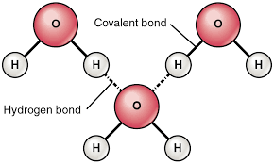](https://www.khanacademy.org/science/class-11-chemistry-india/xfbb6cb8fc2bd00c8:in-in-states-of-matter/xfbb6cb8fc2bd00c8:in-in-intermolecular-forces/a/intramolecular-and-intermolecular-forces)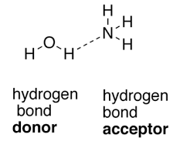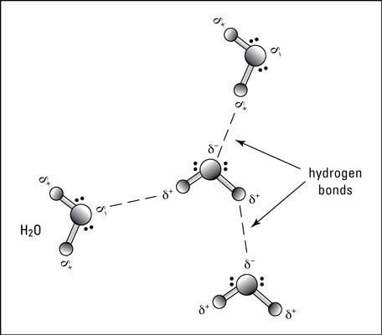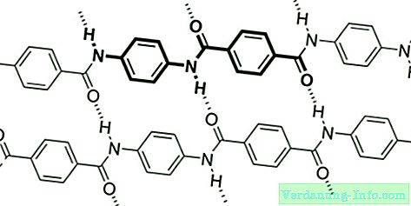[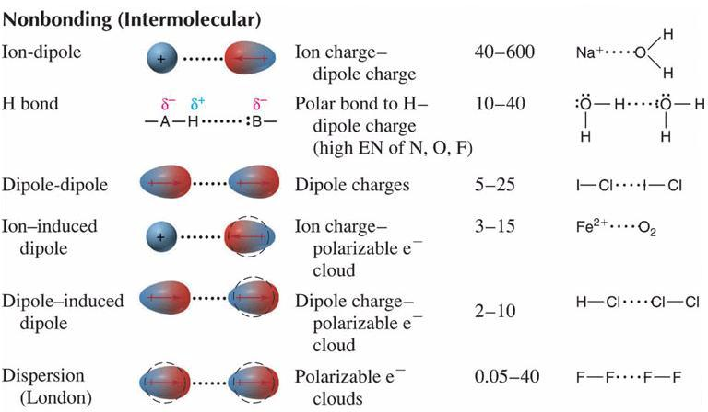](https://www.google.dk/url?sa=i&url=https%3A%2F%2Fwww.chem.fsu.edu%2Fchemlab%2Fchm1046course%2Finterforces.html&psig=AOvVaw1LvZVy2J5tx_nrlUGt7kzb&ust=1586535279639000&source=images&cd=vfe&ved=0CAIQjRxqFwoTCMipxs_e2-gCFQAAAAAdAAAAABAK)

