Genetic fingerprinting for a family (CODIS, 8 loci)
Annabeth: mother, Nikolaj: father, Albert and Oliver: sons
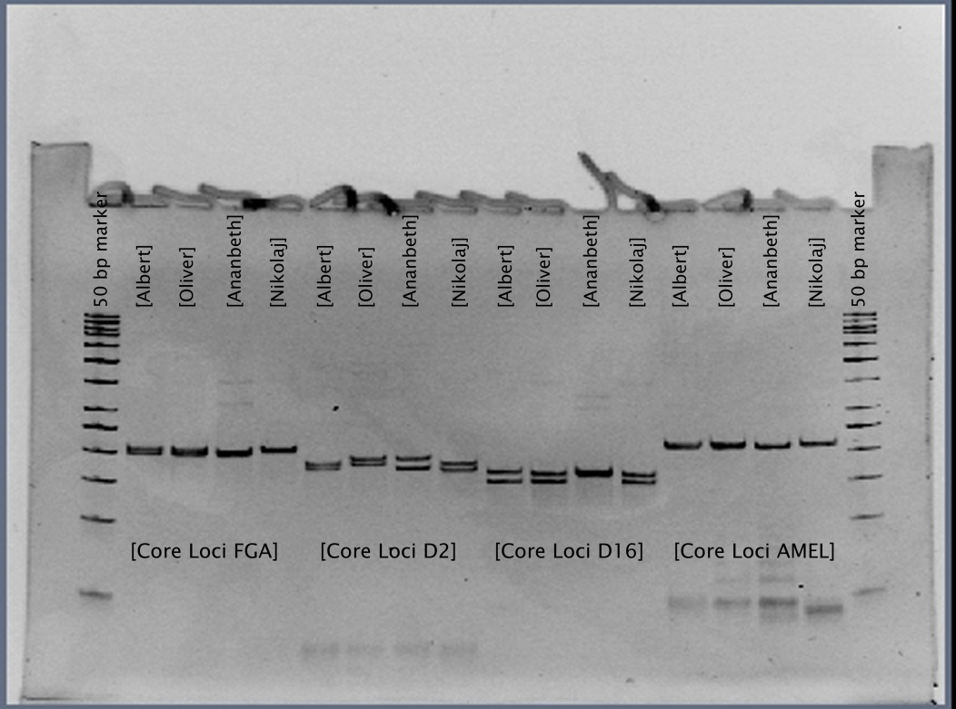
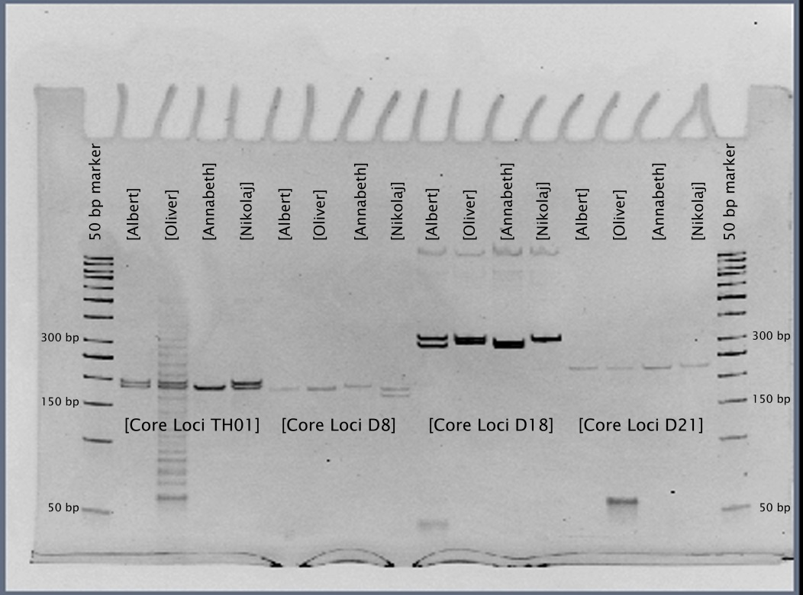
Explain for each core locus, how the sons got their alleles.

