Blood groups
Rhesus system
Phenotypes:
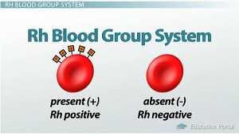
Genotypes:
Fenotype | Genotypes
Rh+ | DD og Dd
Rh- | dd
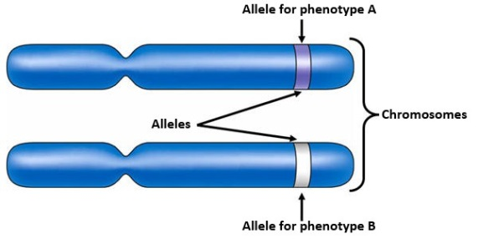
Significance for pregnancy:
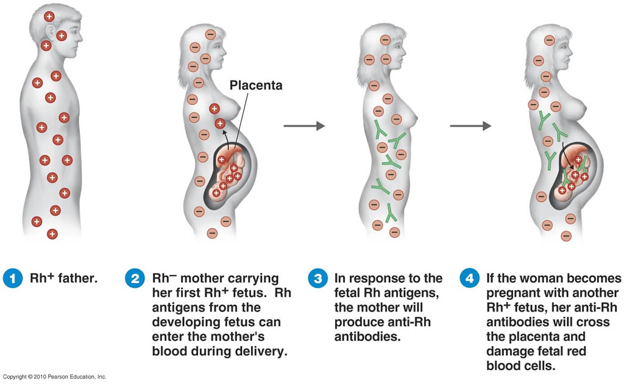

ABO-system
Phenotypes:
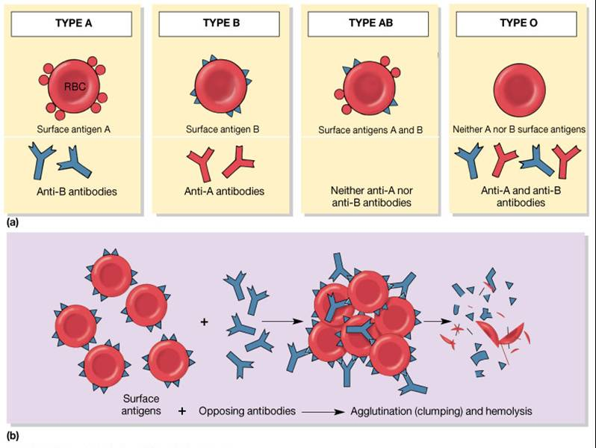
Genotypes:
